**Nguyễn Lê Hoàng Dinh**

**17DTHA6**

**1711061518**

**Chapter 1 Exam**

1. Which term describes the state of a network when the demand on the network resources exceeds the available capacity? congestion
2. Which statement describes the use of powerline networking technology? A device connects to an existing home LAN using an adapter and an existing electrical outlet
3. Match the description to the form of network communication. (Not all options are used.) podcast_an audio-based medium that allows people to deliver their recordings to a wide audience / weblog (blog)_ / social media_interactive websites where people create and share user-generated content with friends and family / wiki_web pages that groups of people can edit and view together / instant messaging_real-time communication between two or more people
4. What is the Internet? It provides connections through interconnected global networks
5. Match each characteristic to its corresponding Internet connectivity type. (Not all options are used.) DSL_high bandwidth connection that runs over telephone line / dialup telephone_typically has very low bandwidth / satellite_not suited for heavily wooded areas / cable_uses coaxial cable as a medium
6. What is a characteristic of a converged network? it delivers data, voice, and video over the same network infrastructure
7. Which two Internet connection options do not require that physical cables be run to the building? (Choose two.) cellular / satellite
8. What security violation would cause the most amount of damage to the life of a home user? capturing of personal data that leads to identity theft
9. Which expression accurately defines the term bandwidth? a measure of the data carrying capacity of the media
10. A network administrator is implementing a policy that requires strong, complex passwords. Which data protection goal does this policy support? data confidentiality
11. A company is contemplating whether to use a client/server or a peer-to-peer network. What are three characteristics of a peer-to-peer network? (Choose three.) less cost to implement / lacks centralized administration / easy to create
12. Which area of the network would a college IT staff most likely have to redesign as a direct result of many students bringing their own tablets and smartphones to school to access school resources? wireless LAN
13. Which networking trend involves the use of personal tools and devices for accessing resources on a business or campus network? BYOD
14. Which two connection options provide an always-on, high-bandwidth Internet connection to computers in a home office? (Choose two.) DSL / cable
15. What type of network must a home user access in order to do online shopping? the Internet
16. Which two statements describe intermediary devices? (Choose two.) Intermediary devices connect individual hosts to the network / Intermediary devices direct the path of the data
17. What two criteria are used to help select a network medium from various network media? (Choose two.) the environment where the selected medium is to be installed / the distance the selected medium can successfully carry a signal
18. A user is implementing security on a small office network. Which two actions would provide the minimum security requirements for this network? (Choose two.) implementing a firewall / installing antivirus software
19. Which statement describes a characteristic of cloud computing? Applications can be accessed over the Internet by individual users or businesses using any device, anywhere in the world
20. An employee at a branch office is creating a quote for a customer. In order to do this, the employee needs to access confidential pricing information from internal servers at the Head Office. What type of network would the employee access? an intranet
21. What are two functions of end devices on a network? (Choose two.) They are the interface between humans and the communication network / They originate the data that flows through the network
22. K
23. What type of network traffic requires QoS? video conferencing
24. Which device performs the function of determining the path that messages should take through internetworks? a router

**Chapter 2 Exam**

1. A network administrator needs to keep the user ID, password, and session contents private when establishing remote CLI connectivity with a switch to manage it. Which access method should be chosen? SSH

***(Trang 35 / 2.1.2.1. Phương thức truy cập / SSH)***

1. Which command or key combination allows a user to return to the previous level in the command hierarchy? Exit

***(Trang 38 / 2.1.3.4 Điều hướng giữa các chế độ IOS / exit)***

1. Which procedure is used to access a Cisco 2960 switch when performing an initial configuration in a secure environment? Use the console port to locally access the switch from a serial or USB interface of the PC

***(Trang 35 / 2.1.2.1. Phương thức truy cập)***

1. What is the function of the kernel of an operating system? The kernel provisions hardware resources to meet software requirements

***(Trang 34 / 2.1.1.1 Hệ điều hành / OS-Kernel)***

1. A router with a valid operating system contains a configuration file stored in NVRAM. The configuration file has an enable secret password but no console password. When the router boots up, which mode will display? user EXEC mode

***(Trang 37 / 2.1.3.2 Các chế độ lệnh chính)***

1. Which information does the show startup-config command display?​ the contents of the saved configuration file in the NVRAM

***(Trang 46 / 2.2.3.1 Lưu cấu hình Running Config vào file)***

1. Why is it important to configure a hostname on a device? to identify the device during remote access (SSH or telnet)
2. Which two host names follow the guidelines for naming conventions on Cisco IOS devices? (Choose two.) RM-3-Switch-2A4 / SwBranch799

***(Trang 42 / 2.2.1.2 Cấu hình hostname)***

1. How does the service password-encryption command enhance password security on Cisco routers and switches? It encrypts passwords that are stored in router or switch configuration files

***(Trang 44 / 2.2.2.3 Mã hóa Password)***

1. Refer to the exhibit. A network administrator is configuring the MOTD on switch SW1. What is the purpose of this command? 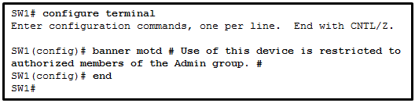

to display a message when a user accesses the switch

***(Trang 45 / 2.2.2.4 Thiết lập thông đệp Banner)***

1. While trying to solve a network issue, a technician made multiple changes to the current router configuration file. The changes did not solve the problem and were not saved. What action can the technician take to discard the changes and work with the file in NVRAM? Issue the reload command without saving the running configuration

***(Trang 46 / 2.2.3.2 Thay đổi Running Config)***

1. Which two functions are provided to users by the context-sensitive help feature of the Cisco IOS CLI? (Choose two.) determining which option, keyword, or argument is available for the entered command / displaying a list of all available commands within the current mode

***(Trang 39 / 2.1.4.3 Tính năng trợ giúp IOS)***

1. What are two characteristics of RAM on a Cisco device? (Choose two.) Issue the reload command without saving the running configuration / The configuration that is actively running on the device is stored in RAM
2. Which interface allows remote management of a Layer 2 switch? the switch virtual interface

***(Trang 49 / 2.3.1.2 Interface và Port)***

1. Match the definitions to their respective CLI hot keys and shortcuts. (Not all options are used.) Tab_completes abbreviated commands and parameters / space bar_displays the next screen / Up Arrow_scrolls backwards through previously entered commands / Ctrl C_ / ?_provides context-sensitive help / Ctrl-Shift-6_aborts commands such as trace and ping

***(Trang 39 / 2.1.4.3 Tính năng trợ giúp IOS / 2.1.4.5 Video-Phím nóng và phím tắt)***

1. What is a user trying to determine when issuing a ping 10.1.1.1 command on a PC? If there is connectivity with the destination device

***(Trang 39 / 2.1.4.2 Cú pháp lệnh IOS)***

1. Which interface is the default SVI on a Cisco switch? VLAN 1

***(Trang 51 / 2.3.2.3 Cấu hình SV1)***

1. Why would a Layer 2 switch need an IP address? to enable the switch to be managed remotely

***(Trang 49 / 2.3.1.2 Interface và Port)***

1. Which statement is true about the running configuration file in a Cisco IOS device? It affects the operation of the device immediately when modified
2. What command can be used on a Windows PC to see the IP configuration of that computer? Ipconfig

***(Trang 51 / 2.3.3.1 Kiểm tra IP trên các Interface)***

1. A technician is adding a new PC to a LAN. After unpacking the components and making all the connections, the technician starts the PC. After the OS loads, the technician opens a browser, and verifies that the PC can reach the Internet. Why was the PC able to connect to the network with no additional configuration? The PC was preconfigured to use DHCP

***(Trang 50 / 2.3.2.2 Cấu hình địa chỉ IP tự động cho thiết bị)***

1. Refer to the exhibit. A network technician is testing connectivity in a new network. Based on the test results shown in the exhibit, which device does the technician have connectivity with and which device does the technician not have connectivity with? (Choose two.) 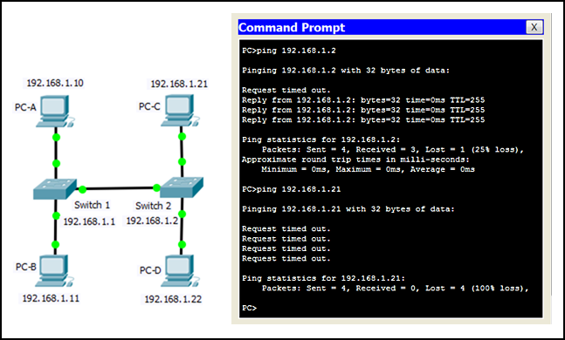no connectivity: PC-C / connectivity: switch 2
2. Refer to the exhibit. What three facts can be determined from the viewable output of the show ip interface brief command? (Choose three.) 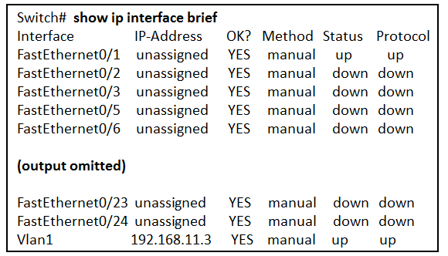One device is attached to a physical interface / The default SVI has been configured / The switch can be remotely managed
3. An administrator is configuring a switch console port with a password. In what order will the administrator travel through the IOS modes of operation in order to reach the mode in which the configuration commands will be entered? (Not all options are used.) interface configuration mode / privileged EXEC mode-second mode / line configuration mode- final mode / global configuration mode- third mode / user EXEC mode- first mode

***(Trang 37 / 2.1.3.2 Các chế độ lệnh chính / 2.1.3.3 Các chế độ lệnh cấu hình)***

**Chapter 3 Exam**

1. At which layer of the OSI model would a logical address be added during encapsulation? network layer

***(Trang 64 / 3.2.4.2 Mô hình tham chiếu OSI)***

1. Refer to the exhibit. HostA is attempting to contact ServerB. Which two statements correctly describe the addressing that HostA will generate in the process? (Choose two.) 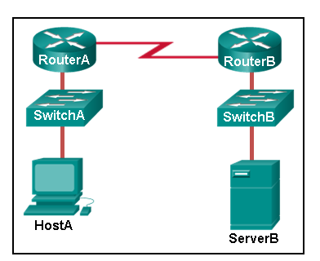

A frame with the destination MAC address of RouterA / A packet with the destination IP address of ServerB

1. Which three layers of the OSI model are comparable in function to the application layer of the TCP/IP model? (Choose three.) session / application / presentation

***(Trang 66 / 3.2.4.4 So sánh giữa mô hình OSI và TCP/IP)***

1. Refer to the exhibit. If Host1 were to transfer a file to the server, what layers of the TCP/IP model would be used?

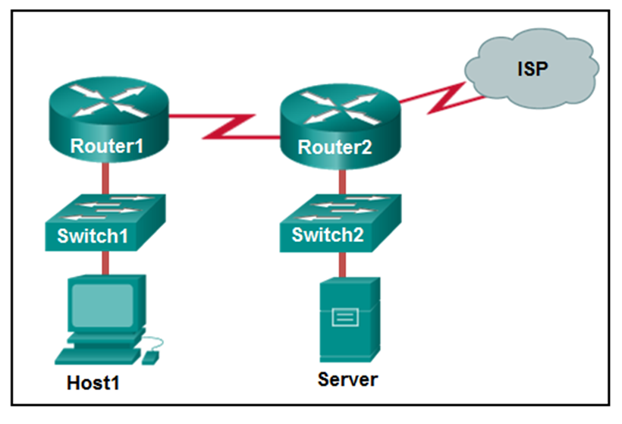

application, transport, Internet, and network access layers

***(Trang 60 / 3.2.2.3 Bộ giao thức TCP/IP)***

1. Match each description to its corresponding term. (Not all options are used.) the process of determining when to begin sending messages on a network_ / the process of converting information from one format into another acceptable for transmission_message encoding / the process of placing one message format inside another message format_message encapsulation / the process of unpacking one message format from another message format_ / the process of breaking up a long message into individual pieces before being sent over the network_message sizing

***(Trang 54+55+46 / 3.1.1.3 Mã hóa thông điệp + 3.1.1.4 Định dạng thông điệp và đóng gói + 3.1.1.5 Kích thước thông điệp)***

1. What three application layer protocols are part of the TCP/IP protocol suite? (Choose three.) DHCP / DNS / FTP

***(Trang 60 / 3.2.2.3 Bộ giao thức TCP/IP)***

1. Which statement is true about the TCP/IP and OSI models? The TCP/IP transport layer and OSI Layer 4 provide similar services and functions

***(Trang 66 / 3.2.4.4 So sánh giữa mô hình OSI và TCP/IP)***

1. What type of communication will send a message to all devices on a local area network? Broadcast

***(Trang 56 / 3.1.1.7 Loại thông điệp)***

1. What will happen if the default gateway address is incorrectly configured on a host? The host cannot communicate with hosts in other networks
2. What is an advantage of using standards to develop and implement protocols? Products from different manufacturers can interoperate successfully
3. What process is used to place one message inside another message for transfer from the source to the destination? Encapsulation

***(Trang 55 / 3.1.1.4 Đinh dạng thông điệp và đóng gói)***

1. Match the protocol function to the description while taking into consideration that a network client is visiting a web site. (Not all options are used.) application protocol_governing the way a web server and a web client interact / internet protocol_taking the segments from the transport protocol, encapsulating them into packets, and assigning them the appropriate addresses / network access protocol_preparing packets to be transmitted over the network media / network time protocol_managing the individual conversations between web servers and web clients

***(Trang 65 / 3.2.4.3 Mô hình TCP/IP)***

1. What are proprietary protocols? protocols developed by organizations who have control over their definition and operation

***(Trang 59 / 3.2.2 Bộ giao thức-3.2.2.1 Bộ giao thức và chuẩn giao thức)***

1. What is an advantage of network devices using open standard protocols? A client host and a server running different operating systems can successfully exchange data
2. Which PDU is processed when a host computer is de-encapsulating a message at the transport layer of the TCP/IP model? Segment

***(Trang 67 / 3.3.1.2 Đơn vị dữ liệu giao thức)***

1. Which statement is correct about network protocols? They define how messages are exchanged between the source and the destination

***(Trang 57 / 3.2.1.2 Giao thức mạng)***

1. A web client is sending a request for a webpage to a web server. From the perspective of the client, what is the correct order of the protocol stack that is used to prepare the request for transmission? HTTP, TCP, IP, Ethernet

***(Trang 58 / 3.2.1.3 Tương tác giao thức)***

1. Which PDU format is used when bits are received from the network medium by the NIC of a host? Frame

***(Trang 67 / 3.3.1.2 Đơn vị dữ liệu giao thức)***

1. Which address does a NIC use when deciding whether to accept a frame? destination MAC address

***(Trang 70 /3.3.2.3 Thiết bị trên cùng một mạng)***

1. Match the description to the organization. (Not all options are used.) ISOC_This organization promotes the open development, evolution, and use of the Internet throughout the world / ISO_This organization is the largest developer of international standards in the world for a wide variety of products and services. It is known for its Open Systems Interconnection (OSI) reference model / EIA_ / IANA_This organization is responsible for overseeing and managing IP address allocation, domain name management, and protocol identifiers

***(Trang 62+63 / 3.2.3.2 Chuẩn Internet + 3.2.3.3 Tổ chức tiêu chuẩn điện tử và truyền thông)***

1. What method can be used by two computers to ensure that packets are not dropped because too much data is being sent too quickly? flow control

***(Trang 56 /3.1.1.6 Thời gian thông điệp / Kiểm soát lưu lượng)***

1. Which characteristic describes the default gateway of a host computer? the logical address of the router interface on the same network as the host computer

**Chapter 4 Exam**

1. A network administrator is designing the layout of a new wireless network. Which three areas of concern should be accounted for when building a wireless network? (Choose three.) security / interference / coverage area

***(Trang 91 / 4.2.4.1 Đặc tính của truyền không dây)***

1. What is the definition of bandwidth? the amount of data that can flow from one place to another in a given amount of time

***(Trang 78 / 4.1.3.2 Băng thông)***

1. What is the function of the CRC value that is found in the FCS field of a frame? to verify the integrity of the received frame
2. What are two examples of hybrid topologies? (Choose two.) point-to-point / full mesh
3. As data travels on the media in a stream of 1s and 0s how does a receiving node identify the beginning and end of a frame?​ The transmitting node inserts start and stop bits into the frame
4. Which layer of the OSI model is responsible for specifying the encapsulation method used for specific types of media? data link

***(Trang 93 / 4.3.1.1 Tầng liên kết dữ liệu)***

1. Refer to the exhibit. The PC is connected to the console port of the switch. All the other connections are made through FastEthernet links. Which types of UTP cables can be used to connect the devices?​

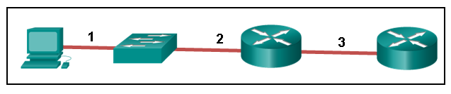

1 - rollover, 2 - straight-through, 3 – crossover

***(Trang 85 / 4.2.2.4 Các loại cáp UTP)***

1. Match the characteristics to the correct type of fiber. (Not all options are used.) Multimode Fiber_LED as light source-several paths of light into the fiber-generally used with LANs / Single-mode Fiber_only one ray of light into the fiber-generally used for campus backbone-laser as light source

***(Trang 88 / 4.2.3.3 Các loại cáp quang)***

1. What is indicated by the term throughput? the measure of the bits transferred across the media over a given period of time

***(Trang 78 /4.1.3.3 Thông lượng)***

1. Which statement describes an extended star topology? End devices connect to a central intermediate device, which in turn connects to other central intermediate devices

***(Trang 100 / 4.4.3.1 Topology vật lý mạng LAN)***

1. What is contained in the trailer of a data-link frame? error detection

***(Trang 93 / 4.3.1.1 Tầng liên kết dữ liệu)***

1. What is one advantage of using fiber optic cabling rather than copper cabling? It is able to carry signals much farther than copper cabling

***(Trang 91 / 4.2.3.7 So sánh cáp quang và cáp đồng)***

1. What are two services performed by the data link layer of the OSI model? (Choose two.) It provides media access control and performs error detection / It accepts Layer 3 packets and encapsulates them into frames

***(Trang 93 / 4.3.1.1 Tầng liên kết dữ liệu)***

1. Which method of data transfer allows information to be sent and received at the same time? full duplex
2. A network administrator notices that some newly installed Ethernet cabling is carrying corrupt and distorted data signals. The new cabling was installed in the ceiling close to fluorescent lights and electrical equipment. Which two factors may interfere with the copper cabling and result in signal distortion and data corruption? (Choose two.) RFI​ / EMI

***(Trang 80 / EMI – RFI)***

1. Which type of connector does a network interface card use? RJ-45
2. What is true concerning physical and logical topologies? Logical topologies refer to how a network transfers data between devices

***(Trang 97 / 4.4.1.2 Topology vật lý và logical)***

1. What technique is used with UTP cable to help protect against signal interference from crosstalk? twisting the wires together into pairs

***(Trang 80 / 4.2.1.3 Cáp xoắn đôi không có vỏ bọc (UTP))***

1. What is a role of the Logical Link Control sublayer? to mark frames to identify the network layer protocol being carried

***(Trang 94 / 4.3.1.2 Hai tầng con trong tầng liên kết dữ liệu)***

1. Which characteristic describes crosstalk? the distortion of the transmitted messages from signals carried in adjacent wires

***(Trang 80 / Crosstalk)***

1. Refer to the exhibit. What is wrong with the displayed termination?

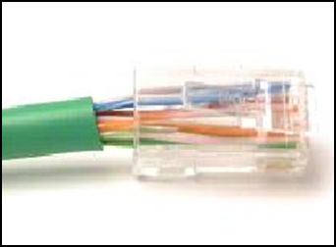

The untwisted length of each wire is too long

1. What are two reasons for physical layer protocols to use frame encoding techniques? (Choose two.) to distinguish data from control information / to identify where the frame starts and ends

***(Trang 73 / 4.1.2.1 Tầng vật lý)***

1. Why are two strands of fiber used for a single fiber optic connection? They allow for full-duplex connectivity

***(Trang 89 / 4.2.3.4 Đầu nối cáp quang)***

**Chapter 5 Exam**

1. Which destination address is used in an ARP request frame? FFFF.FFFF.FFFF

***(Trang 110 / 5.1.2.6 Địa chỉ MAC Broadcast)***

1. Refer to the exhibit. The switches are in their default configuration. Host A needs to communicate with host D, but host A does not have the MAC address for its default gateway. Which network hosts will receive the ARP request sent by host A?

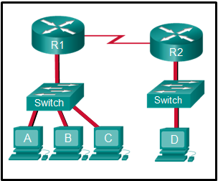

only hosts B, C, and router R1

1. True or False?

When a device is sending data to another device on a remote network, the Ethernet frame is sent to the MAC address of the default gateway true

1. What is a characteristic of port-based memory buffering? Frames are buffered in queues linked to specific ports

***(Trang 117 / 5.2.2.3 Bộ nhớ đệm trên switch)***

1. What is auto-MDIX? a feature that detects Ethernet cable typ​e

***(Trang 118 / 5.2.3.2 Auto-MDIX)***

1. What are two potential network problems that can result from ARP operation? (Choose two.) Network attackers could manipulate MAC address and IP address mappings in ARP messages with the intent of intercepting network traffic / On large networks with low bandwidth, multiple ARP broadcasts could cause data communication delays

***(Trang 120 / 5.3.2 ARP)***

1. What happens to runt frames received by a Cisco Ethernet switch? The frame is dropped

***(Trang 108 / 5.1.1.4 Các trường hợp trong Ethernet Frame)***

1. The ARP table in a switch maps which two types of address together? Layer 3 address to a Layer 2 address
2. Match the characteristic to the forwarding method. (Not all options are used.) cut-through_has low latency-may forward runt frames-begin forwarding when the destination address is received / store-and-forward_always stores the entire frame-checks the CRC before forwarding-checks the frame length before forwarding

***(Trang 116 / 5.2.2.1 Phương thức chuyển tiếp trong switch cisco)***

1. Refer to the exhibit. The exhibit shows a small switched network and the contents of the MAC address table of the switch. PC1 has sent a frame addressed to PC3. What will the switch do with the frame?

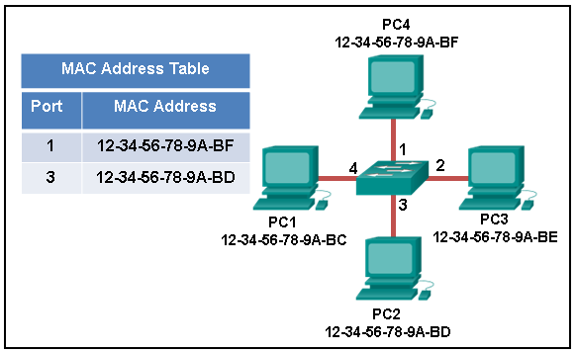

The switch will forward the frame to all ports except port 4

1. What statement describes Ethernet? It defines the most common LAN type in the world

***(Trang 106 / 5.1.1.1 Đóng gói Ethernet)***

1. What statement describes a characteristic of MAC addresses? They must be globally unique

***(Trang 109 / 5.1.2.2 Địa chỉ MAC: nhận dạng Ethernet)***

1. Refer to the exhibit. A switch with a default configuration connects four hosts. The ARP table for host A is shown. What happens when host A wants to send an IP packet to host D?

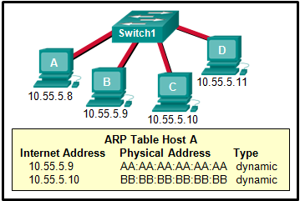

Host A sends out a broadcast of FF:FF:FF:FF:FF:FF. Every other host connected to the switch receives the broadcast and host D responds with its MAC address

1. What is the minimum Ethernet frame size that will not be discarded by the receiver as a runt frame? 64 bytes

***(Trang 108 / 5.1.1.4 Các trường hợp trong Ethernet Frame)***

1. What is the aim of an ARP spoofing attack? to associate IP addresses to the wrong MAC address

***(Trang 124 / 5.3.3.2 ARP Spoofing)***

1. What addressing information is recorded by a switch to build its MAC address table? the source Layer 2 address of incoming frames

***(Trang 112 / 5.2.1.1 Nguyên tắc cơ bản của switch)***

1. Which two statements describe features or functions of the logical link control sublayer in Ethernet standards? (Choose two.) The data link layer uses LLC to communicate with the upper layers of the protocol suite / Logical link control is implemented in software

***(Trang 106 / 5.1.1.1 Đóng gói Ethernet)***

1. Which statement is true about MAC addresses? The first three bytes are used by the vendor assigned OUI

***(Trang 109 / 5.1.2.2 Địa chỉ MAC: nhận dạng Ethernet)***

1. Which statement describes the treatment of ARP requests on the local link? They are received and processed by every device on the local network
2. What are the two sizes (minimum and maximum) of an Ethernet frame? (Choose two.) 64 bytes / 1518 bytes

***(Trang 108 / 5.1.1.4 Các trường hợp trong Ethernet Frame)***

1. Refer to the exhibit. PC1 issues an ARP request because it needs to send a packet to PC2. In this scenario, what will happen next?

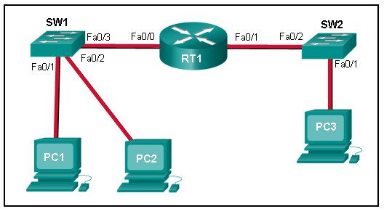

PC2 will send an ARP reply with its MAC address

1. Which switching method uses the CRC value in a frame? store-and-forward

***(Trang 116 / 5.2.2.1 Phương thức chuyển tiếp trong switch cisco)***

**Chapter 6 Exam**

1. What are two types of router interfaces? (Choose two.) LAN / WAN

***(Trang 146 / 6.3.1.6 Cổng LAN và WAN trên Router)***

1. Open the PT Activity. The enable password on SW1 is cisco.Perform the tasks in the activity instructions and then answer the question.

For what reason is the failure occurring?​

SW1 does not have a default gateway configured

1. Which characteristic describes an IPv6 enhancement over IPv4?​ The IPv6 header is simpler than the IPv4 header is, which improves packet handling

***(Trang 134 / Ưu điểm của IPV6 so với IPV4 khi sử dụng tiêu đề đơn giản hơn)***

1. What IPv4 header field identifies the upper layer protocol carried in the packet? Protocol

***(Trang 131 / 6.1.3.1 Tiêu đề của gói tin IPv4)***

1. Match the command with the device mode at which the command is entered. (Not all options are used.) R1(config)#_service password-encryption / R1>_enable / R1(config-router)#_ / R1#_copy running-config startup-config / R1(config-line)#_login / R1(config-if)#_ip address 192.168.4.4 255.255.255.0

***(Trang 150 / 6.4.1.1 Các bước cấu hình cơ bản switch)***

1. What routing table entry has a next hop address associated with a destination network? remote routes

***(Trang 141 / 6.2.2.6 Địa chỉ Next-hop)***

1. Which field in the IPv4 header is used to prevent a packet from traversing a network endlessly? Time-to-Live

***(Trang 131 / 6.1.3.1 Tiêu đề của gói tin IPv4)***

1. A router boots and enters setup mode. What is the reason for this? The configuration file is missing from NVRAM
2. What is the purpose of the startup configuration file on a Cisco router? to contain the commands that are used to initially configure a router on startup

***(Trang 147 / 6.3.2.1 Các Files Boot)***

1. Following default settings, what is the next step in the router boot sequence after the IOS loads from flash? Locate and load the startup-config file from NVRAM

***(Trang 147 / 6.3.2.2 Tiến trình Boot của Router)***

1. Which statement describes a hardware feature of a Cisco 1941 router that has the default hardware configuration? It has two types of ports that can be used to access the console

***(Trang 146 / Router Cisco 1941 bao gồm các cổng và kết nối sau: Cổng giao diện điều khiển (Console))***

1. What type of route is indicated by the code C in an IPv4 routing table on a Cisco router? directly connected route

***(Trang 139 / 6.2.2.3 Video demo – Giới thiệu bảng định tuyến Ipv4)***

1. Which two pieces of information are in the RAM of a Cisco router during normal operation? (Choose two.) Cisco IOS / IP routing table

***(Trang 144 / 6.3.1.3 Bộ nhớ của Router)***

1. Which three commands are used to set up secure access to a router through a connection to the console interface? (Choose three.) line console 0 / login / password cisco

***(Trang 150 / 6.4.1.1 Các bước cấu hình cơ bản switch)***

1. Refer to the exhibit. R1 receives a packet destined for the IP address 192.168.2.10. Out which interface will R1 forward the packet?

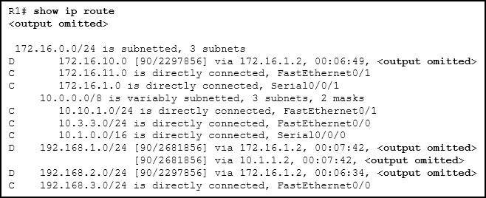

Serial0/0/1

1. What is one advantage that the IPv6 simplified header offers over IPv4? efficient packet handling

***(Trang 134 / Ưu điểm của IPV6 so với IPV4 khi sử dụng tiêu đề đơn giản hơn)***

1. Refer to the exhibit.Which route from the PC1 routing table will be used to reach PC2?

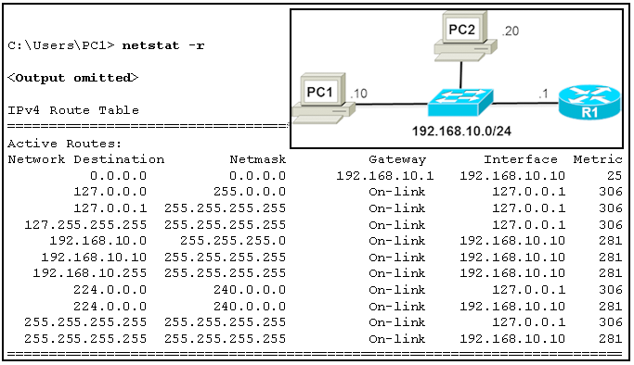

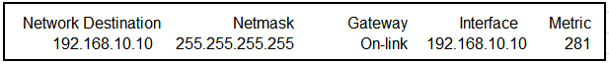

1. Which characteristic of the network layer in the OSI model allows carrying packets for multiple types of communications among many hosts? the ability to operate without regard to the data that is carried in each packet
2. When a connectionless protocol is in use at a lower layer of the OSI model, how is missing data detected and retransmitted if necessary? Upper-layer connection-oriented protocols keep track of the data received and can request retransmission from the upper-level protocols on the sending host
3. What are two characteristics of IP? (Choose two.) does not require a dedicated end-to-end connection / operates independently of the network media

***(Trang 129+130 / 6.1.2.3 IP-Liên kết không kết nối + 6.1.2.5 IP-Độc lập phương tiện truyền dữ liệu)***

**Chapter 7 Exam**

1. Which three IP addresses are private ? (Choose three.) 192.168.5.5 / 172.16.4.4 / 10.1.1.1

***(Trang 165 / 7.1.4.1 Địa chỉ IPv4 public)***

1. A user is executing a tracert to a remote device. At what point would a router, which is in the path to the destination device, stop forwarding the packet? when the value in the TTL field reaches zero
2. What is indicated by a successful ping to the ::1 IPv6 address? IP is properly installed on the host

***(Trang 183 / 7.3.2.1 Ping-kiểm tra tầng giao thức)***

1. What field content is used by ICMPv6 to determine that a packet has expired? Hop Limit field
2. Which two parts are components of an IPv4 address? (Choose two.) host portion / network portion

***(Trang 159 / 7.1.2.1 Vị trí host và network)***

1. What is the decimal equivalent of the binary number 10010101? 149
2. Which of these addresses is the shortest abbreviation for the IP address: 3FFE:1044:0000:0000:00AB:0000:0000:0057? 3FFE:1044:0:0:AB::57
3. What is the purpose of ICMP messages? to provide feedback of IP packet transmissions

***(Trang 182 / 7.3.1 ICMP)***

1. What field content is used by ICMPv6 to determine that a packet has expired? Hop Limit field
2. What are two types of IPv6 unicast addresses? (Choose two.) link-local / loopback

***(Trang 173 / 7.2.3.3 Địa chỉ IPv6 Unicast)***

1. Match each description with an appropriate IP address. (Not all options are used.) 64.102.90.23_ / 169.254.1.5_a link-local address / 192.0.2.123_a TEST-NET address / 240.2.6.255_an experimental address / 172.19.20.5_a private address / 127.0.0.1_a loopback address

***(Trang 165 / 7.1.4.2 Xác định địa chỉ IPv4 đang sử dụng)***

1. Which two things can be determined by using the ping command? (Choose two.) *the destination device is reachable through the network / the average time it takes a packet to reach the destination and for the response to return to the source*

***(Trang 183 / 7.3.2 Kiểm tra thiết lập)***

1. Which protocol supports Stateless Address Autoconfiguration (SLAAC) for dynamic assignment of IPv6 addresses to a host? ICMPv6

***(Trang 176 / 7.2.4.3 Cấu hình động – SLAAC)***

1. What subnet mask is represented by the slash notation /20? 255.255.240.0
2. What is the decimal equivalent of the hex number 0x3F? 63
3. What is the purpose of the subnet mask in conjunction with an IP address? to determine the subnet to which the host belongs

***(Trang 159 / 7.1.2.2 Subnet mask)***

1. What is the binary equivalent of the decimal number 232? 11101000
2. What are three characteristics of multicast transmission? (Choose three.) Multicast transmission can be used by routers to exchange routing information / A single packet can be sent to a group of hosts / The range of 224.0.0.0 to 224.0.0.255 is reserved to reach multicast groups on a local network

***(Trang 164 / 7.1.3.6 Địa chỉ Multicast)***

1. What are three parts of an IPv6 global unicast address? (Choose three.) an interface ID that is used to identify the local host on the network / a subnet ID that is used to identify networks inside of the local enterprise site / a global routing prefix that is used to identify the network portion of the address that has been provided by an ISP

***(Trang 174 / 7.2.4.1 Cấu trúc địa chỉ IPv6 Global Unicast)***

1. What does the IP address 172.17.4.250/24 represent? host address
2. An administrator wants to configure hosts to automatically assign IPv6 addresses to themselves by the use of Router Advertisement messages, but also to obtain the DNS server address from a DHCPv6 server. Which address assignment method should be configured? stateless DHCPv6

***(Trang 177 / 7.2.4.4 Cấu hình động – DHCPv6)***

1. What type of address is automatically assigned to an interface when IPv6 is enabled on that interface? link-local

***(Trang 173 / 7.2.3.4 Địa chỉ IPv6 link-local Unicast)***

1. Which two IPv4 to IPv6 transition techniques manage the interconnection of IPv6 domains? (Choose two.) tunneling / dual stack

***(Trang169 / 7.2.1.2 Tồn tại cùng lúc IPv4 và IPv6)***

1. A message is sent to all hosts on a remote network. Which type of message is it? directed broadcast

***(Trang 164 / 7.1.3.5 Địa chỉ Broadcast)***